1.Write a program to set your age and name by instance method.

Program :

class AgeNameMethod

{

public void age(int a)

{

System.out.println("Age is :" + a);

}

public void name(String nam)

{

System.out.println("Name is :" + nam);

}

public static void main(String args[])

{

AgeNameMethod obj = new AgeNameMethod();

obj.age(30);

obj.name("Treasa");

}

}

Output :

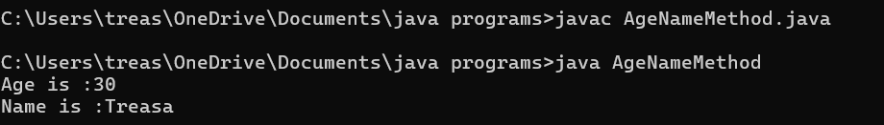

2.Write a program to find the factorial of a number(instance method).

Program :

class Factorial

{

public void fact(int num)

{

int factorial = 1;

for(int i=1;i<=num;i++)

{

factorial = factorial\*i;

}

System.out.println("Factorial of " + num + " is " + factorial);

}

public static void main(String[] args)

{

Factorial obj = new Factorial();

obj.fact(5);

}

}

Output :

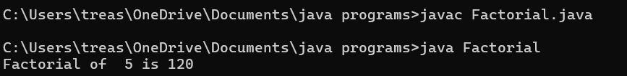

3.Write a program to check whether a number is palindrome/not by using instance method.

Method 1-to find the reverse

Method 2- to check palindrome /not

Program :

class CheckPalindrome

{

public int palin(int num)

{

int rev = 0;

while(num>0)

{

int digit = num%10;

rev = rev \*10 +digit;

num = num/10;

}

return rev;

}

public void checkpalin(int n,int v)

{

if(n == v)

{

System.out.println("Number is palindrome");

}

else

{

System.out.println("Number is not palindrome");

}

}

public static void main (String[] args)

{

CheckPalindrome obj = new CheckPalindrome();

int val = obj.palin(1234);

System.out.println("Reverse is :" +val); //321

obj.checkpalin(1234,val);

}

}

Output :

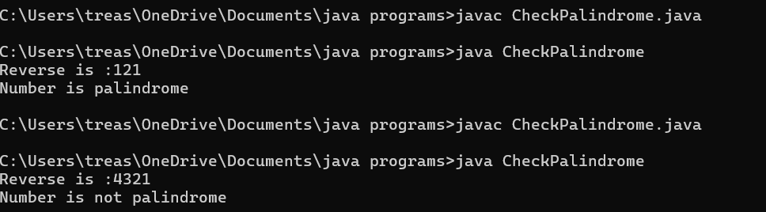

4.Write a program to check whether candidate is eligible for voting (Use instance method and return boolean type).

Program :

class VoteEligibility

{

public boolean vote(int age)

{

if (age>=18)

{

return true;

}

else

{

return false;

}

}

public static void main(String[] args)

{

VoteEligibility obj = new VoteEligibility();

int age = 1;

System.out.println("Age is :" + age);

Boolean a = obj.vote(age);

if(a== true)

{

System.out.println("Eligible for vote");

}

else

{

System.out.println("Not Eligible for vote");

}

}

}

Output :

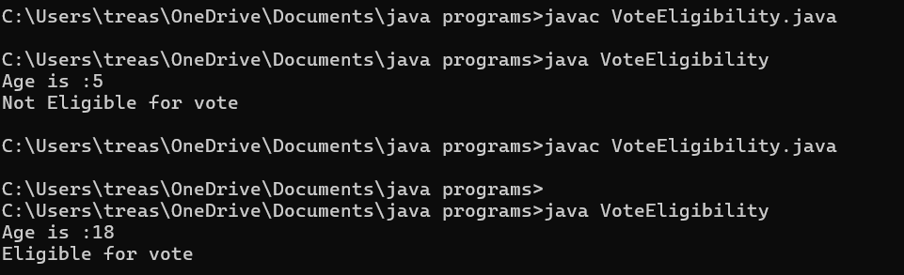

5. Write a program to check whether the customer have discount(get 20% discount if total amount is greater than 5000 ) or not and get the final amount in main method(instance method).Get priced of items using parameterized method.

Method 1 – Calculate total amount

Method 2 - Check discount.

Program :

class Discount

{

public float amount( float a,float b,float c)

{

float tamount = a+b+c;

return tamount;

}

public boolean checkdiscount(float total)

{

if(total>=5000)

{

return true;

}

else

{

return false;

}

}

public static void main (String args[])

{

Discount obj = new Discount();

float total = obj.amount( 100.10f,200.10f,300.11f);

System.out.println("Total price is :" +total);

boolean dis= obj.checkdiscount(total);

if(dis== true)

{

System.out.println("Eligible for discount");

float discountamount = (total\*20)/100;

System.out.println("Discount =" + discountamount);

float finalamount= total-discountamount;

System.out.println("Amount need to pay after disount =" + finalamount);

}

else

{

System.out.println("Not eligible for discount");

System.out.println("Amount = " +total);

}

}

}

Output :

